

Database Management System CSE 303

**Air Quality Monitoring System Final Report**

**Group 02**

# Student Name ID

**CHAPTER 01 : INTRODUCTION 6**

1. BACKGROUND OF THE ORGANIZATION 6
2. BACKGROUND OF THE PROJECT 6
3. OBJECTIVE OF THE PROJECT 6
4. SCOPE OF THE PROJECT 7

**CHAPTER 02 : REQUIREMENT ANALYSIS 8**

1. RICH PICTURE (AS IS) 8

Figure 2. 1: Rich Picture (As Is) 8

1. SIX ELEMENT ANALYSIS (AS IS) 9

Table 2. 1: Six Element Analysis (As Is) 9

1. PROCESS DIAGRAM (AS IS) 30

Figure 2. 2: Process Diagram for Data Entry (As Is) 30

Figure 2. 3: : Process Diagram for Data Validation and Update (As Is) 30

Figure 2. 4: Process Diagram for Viewing (As Is) 31

Figure 2. 5: Process Diagram for Air Quality Report Generation (As Is) 31

1. PROBLEM ANALYSIS 33

Table 2. 2 : Problem Analysis 33

1. RICH PICTURE (TO BE) 39

Figure 2. 7: Rich Picture (To Be) 39

1. SIX ELEMENT ANALYSIS (TO BE) 40

Table 2. 3: Six Element Analysis (To Be) 40

1. PROCESS DIAGRAM (TO BE) 75

Figure 2. 8: Process Diagram for Data Entry (To Be) 75

Figure 2. 9: Process Diagram for Data Verification , Validation and Update (To Be) 75

Figure 2. 10: Process Diagram for Report Generation and Analysis (To Be) 77

**CHAPTER 03 : LOGICAL SYSTEM DESIGN 78**

1. BUSINESS RULE 78
2. Entity Relationship Diagram 81

Figure 3. 1: Entity Relationship Diagram of AQM system 81

1. ENTITY RELATION DIAGRAM TO RELATION SCHEMA 82

Figure 3. 2: Entity Relation Diagram to Relation Schema for SREDA 82

1. NORMALIZATION 83

Figure 3. 3: Normalization for AQM system 83

1. DATA DICTIONARY 84

Table 3. 1: mobile_sensor_table Data Dictionary 84

Table 3. 2: weather_station_table Data Dictionary 85

Table 3. 3: data_source_table Data Dictionary 86

Table 3. 4: mobile_sensor_data_table Data Dictionary 88

Table 3. 5: weather_station_data_table Data Dictionary 89

Table 3. 6: user_table Data Dictionary 89

Table 3. 7: message_table Data Dictionary 90

**CHAPTER 04 : PHYSICAL SYSTEM DESIGN 103**

1. INPUT FORM
   1. Login Page 103

Figure 4. 1: Login Page 103

* 1. Add air quality data using form 105

Figure 4. 3: Adding air quality data using form 105

* 1. Add various types of air quality data from a CSV file 106

Figure 4. 4: Adding various types of air quality data using a CSV form 106

1. OUTPUT FORM 107
   1. Location-based daily Air Quality Index (AQI) visualization in a dashboard 107

Figure 4. 5: Showing Location-based daily Air Quality Index (AQI) visualization in a dashboard 107

* 1. Comparison between multiple data sources 108

Figure 4. 6: Comparison between multiple data sources 108

* 1. Data visualization of the daily Air Quality Index (AQI) per division on a map of Bangladesh, with color labeling based on the AQI, 110

Figure 4. 7: Showing daily Air Quality Index (AQI) per division on a map of Bangladesh, with color labeling based on the AQI 110

* 1. Division-Wise Time-based Air Quality Index (AQI) data visualization using line charts 111

Figure 4. 8: Showing Division-Wise Time-based Air Quality Index (AQI) data visualization using line charts 111

* 1. Division-Wise daily AQI data visualization using line charts, 112

Figure 4. 9: Showing Division-Wise daily AQI data visualization using line charts 112

* 1. Station-Wise AQI data visualization using a box plot 113

Figure 4. 10: Showing Station-Wise AQI data visualization using a box plot 113

* 1. Season-Wise time based AQI data visualization using box plot, 115

Figure 4. 11: Showing Season-Wise time based AQI data visualization using box plot, 115

* 1. Yearly average AQI data visualization using Bar Charts, 116

Figure 4. 12: Showing Yearly average AQI data visualization using Bar Charts 116

* 1. Route-Wise AQI data visualization on a Map, 117

Figure 4. 13: Showing Route-Wise AQI data visualization on a Map, 117

**CHAPTER 05 : CONCLUSION 136**

1. PROBLEM AND SOLUTION 136
2. ADDITIONAL FEATURE AND FUTURE DEVELOPMENT 136
3. CONCLUSION & RECOMMENDATIONS 137

**REFERENCES 138**



**CHAPTER 01 : INTRODUCTION**



**BACKGROUND OF THE ORGANIZATION**

The CASE project has been entrusted with a pivotal role of generating and supplying regular air quality data to the policy makers, stakeholders, and the public. The results of the air quality monitoring basically show how important and how much emission from sources has to be controlled. Monitoring data analysis can often be used to determine the presence and kind (point, area/volume, etc.) of sources contributing to air pollution at a particular location (both chemical and statistical). Results of air quality monitoring also show the impact of pollution control measures implemented by the government of a city or a country. For example, the findings of the air monitoring confirmed a 40% increase in the city of Dhaka's air quality after the phase-out of two-stroke, three-wheel baby taxis in 2001. (Begum et al. 20064 ). This report's primary goal is to publish, analyze, and make available to the public, stakeholders, academics, and policymakers the air quality data collected at 8 major Bangladesh cities.



**BACKGROUND OF THE PROJECT**

The air quality Monitoring System(AQM) is a technique for tracking daily air quality in any city or nation. It indicates whether the air is clean or contaminated and what potential health impacts there may be for the general public. The AQM focuses on potential health impacts that could occur hours or days after breathing contaminated air.



**OBJECTIVE OF THE PROJECT**

The project's overarching goal is to encourage the adoption of sustainable environmental initiatives in significant polluting industries, with an emphasis on reducing air pollution and creating side effects by introducing energy-efficient equipment. Purpose of AQM

1.Public disclosure of daily air quality conditions 2.Explain the effects of air quality on health.

1. Defend the public's interest while reducing emissions 4.Anticipated degree of air pollution



**SCOPE OF THE PROJECT**

Through the following tasks, the project's scope is to be helped in its efficient and effective implementation:

* Assist with implementation, including management and planning
* Monitor the project, including the evaluation of its components by engineers and other technical professionals.
* Assistance with project implementation review and enhancement

Data collection, measure characterization, potential modeling, program analysis, reporting, project management, project initiation



**CHAPTER 02 : REQUIREMENT ANALYSIS**



**RICH PICTURE (AS IS)**

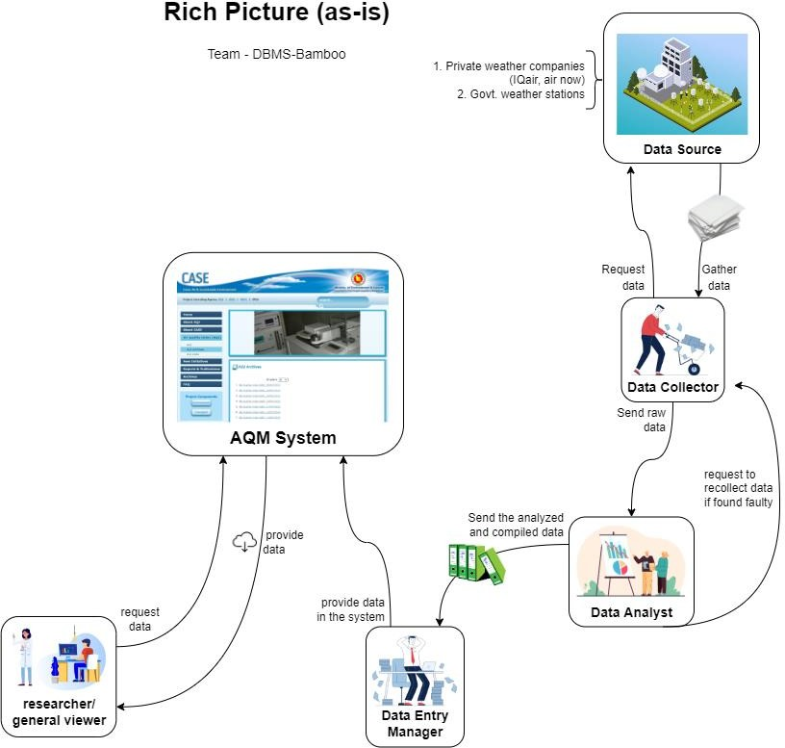

Figure 2. 1: Rich Picture (As Is)



**SIX ELEMENT ANALYSIS (AS IS)**

Table 2. 1: Six Element Analysis (As Is)

|  |  |  |  |  |  |  |
| --- | --- | --- | --- | --- | --- | --- |
| **Process** | **System Roles** | | | | | |
| **Human** | **Non-computing Hardware** | **Computing hardware** | **Software** | **Database** | **Communication & Network** |
| **Basic Data Entry** | 1. **Data Collector:**    1. Gather air quality data from enlisted sources    2. Send the raw data to Data Analyst 2. **Data Analyst:**    1. Received the raw data from the data source.    2. Send the   analyzed and compiled data to the data entry Manager | **A. Paper and stationery**   1. Data collectors use it to manually jot down the data from the data sources 2. Papers can be used for printing purposes to keep a manual database.   **B. File Holder**   1. It is used to organize the papers | **A. PC/ Laptop/ Other computing device**  1. Various computing devices can be used to visualize, store and compile raw data   1. **Printer**    1. printer used to print data from data sources    2. It is used to make manual pdf 2. **Server**    1. Database uses the server to store the monthly air quality reports    2. AQM System is hosted in the server | 1. **AQM system**    1. Interface which stores data and used by the Data Entry Manager to enter the data manually in the data entry form 2. **Operating system**    1. Any operating system used by a Data Entry Manager. Eg : Mac, Windows, Linux etc | **A. Database of AQM**  1. System uses the Database to store the monthly air quality reports   1. **Physical log book**    1. It is used to keep physical records of the monthly reports | 1. **Telephone**    1. Can be utilized by data collectors to contact data providers.    2. Can be used by the Data Collectors to call the Data Analyst to notify about their task being done.    3. Can be used by the Data Entry Manager to delegate tasks to Data Collectors. 2. **Internet**    1. Internet connection is required to use the AQM system and use it’s functionalities like login, logout, data entry and viewing |

|  |  |  |  |  |  |  |
| --- | --- | --- | --- | --- | --- | --- |
|  | .**C. Data Entry Manager:**   1. Received the compiled and analyzed document from data Analyst. 2. Provide the data into the system 3. Log into AQM 4. Select appropriate data entry form 5. Enter the data in the system. User needs to provide location, AQI, air quality state and range 6. Click the save button to save the data in the system | 1. To make   physical reports   1. To send to the data Analyst.   **C. File Cabinet (Physical Archive)**   1. It is used for storing the printed data version as a manual backup. |  |  |  | 2. Used by Data Entry Manager to enter data in AQM   1. **Email**    1. Data Entry Manager can email other polapans to notify about any moner madhuri they want. |
| **Data Validation & Update** | **A. Data Collector**  1. Once received a request to recollect data | **A. Paper and Stationary**  1. Data collectors use it to manually jot down the | **A. PC/ Laptop/ Other computing device**  1. Used by the Data Analyst to observe the data trend. ( If found faulty, the verification process starts | 1. **AQM System**    1. The system verifies the users and shows the appropriate interface    2. The software used for viewing the monthly Air | 1. **Database of AQM**    1. System uses the Database to store the updated monthly | 1. **Telephone**    1. It can be used by the Data Analyst to call the Data Collectors to give updates about their task. 2. **Internet** |

|  |  |  |  |  |  |  |
| --- | --- | --- | --- | --- | --- | --- |
|  | from the Data Analyst, they start recollecting the data.   1. They gather air quality data from enlisted sources. 2. Make a   physical report of the collected raw data.   1. Send the   physical report to the Data Analyst..  **B.Data Analyst**   1. Request the Data Collector to recollect the data after it is found faulty. 2. After receiving the collected data Make a physical report of the collected raw data. | corrected data from the data sources   1. Papers can be used for printing purposes to keep a physical record 2. Used by the Data Analyst to jot down the data which seemed faulty with the physical document. 3. **Seal stamp**    1. Used by Data Entry Manager to stamp the verified physical document 4. **Cabinet**    1. It is used for storing the printed data version (the physical document) as a manual backup 5. **File Holder**    1. It is used by the Data Entry Manager to | once he requests Data Collector to recollect the data)   1. Used by the Data Entry Manager to new data in the AQM system. 2. Used by the users to log in the AQM system 3. Data Entry Manager will also store the updated data in the computer as a backup. 4. **Printer**    1. Data Analyst can print the data trend in the paper and observe it to make a decision. 5. **Pendrive**    1. Data Entry Manager can keep the updated physical document in the pendrive to store it as a backup. 6. **Server**    1. Database uses the server to store the updated air quality reports.    2. The AQM System is hosted on the server.    3. The data in the AQM System is provided from the server. | Quality Reports by the Admin   1. It is used to update the faulty data through a form 2. Data Analyst uses it to compare the data trend again with the physical document to identify the faulty data. 3. **Operating System**    1. Any operating system used by a Data Entry Manager. Eg : Mac, Windows, Linux etc 4. **Application Software**    1. Data Entry Manager can initially make a draft of the form in MS Word/ Ms Excel and then finalize it in the AQM system. 5. **PDF Viewer**    1. User can view the data trend in the pdf version. | air quality reports   1. **Physical log book**    1. It is used to keep physical records of the monthly reports    2. The record of data being updated is kept here | 1. Internet connection is required to use the AQM system and use it’s functionalities like login, logout, data entry, viewing and updating 2. Used by Data Entry Manager to update data in AQM System 3. **Email**    1. A Data Analyst can email the data collector to let them know about anomalous data.    2. The Data Collector can inform the analyst after recollecting the data. |

|  |  |  |  |  |  |  |
| --- | --- | --- | --- | --- | --- | --- |
|  | 3. Send the  physical report to the Data entry manager... | organize the documents   1. To make   physical reports   1. To send to the data entry managers 2. **Journal /**   **Research Paper/ Books / Newspaper**   * 1. Data Analysts can use these to analyze when verifying the updated data again. |  |  |  |  |
| **4.**  **Viewing** | 1. **Researcher/ General**   **Viewer**   * 1. Logs into the AQM system.(user not validated as logged in as guest)   2. Request for Data   3. System   provides the data | **A. Paper**   1. Used for   printing purposes by the Researcher. | 1. **PC/ Laptop/ Other computing device**    1. Used by   Researcher/general viewers to view reports, from the AQM system.   1. **Printer**    1. Researchers can use it to print   **D. Routers/ Internet Cables by ISP Providers** | 1. **AQM System**    1. The system validates and verifies the users.    2. Provides an appropriate interface for the users.    3. Used for viewing the monthly Air Quality data trends/ graphs, reports by , researchers/general viewers. 2. **Operating System** | **A. Database of AQM System**   1. AQM database stores information of all the appropriate users.( this is useful while the system validates the user while | **A. Internet**   1. Internet connection used by Researcher/general viewers and to log in, log out, viewing the AQM system.   .   1. Used when the AQM system is storing all the data. |

|  |  |  |  |  |  |  |
| --- | --- | --- | --- | --- | --- | --- |
|  |  |  | 1. From the networking side, internet cables by the ISP providers or routers are used by the Researcher/General Viewers. | 1. Any operating system used by the researcher /general viewer. . Eg : Mac, Windows, Linux etc.   1. **Application Software**    1. Researchers/general viewers can jot down important notes by using MS Word. 2. **PDF Viewer**    1. Researchers/general viewers can view the data trends / graphs , reports in the PDF version. 3. **Web- based Application Software**    1. Researchers/general viewers use browsers to log in into the AQM system.    2. Researchers/general viewers use to view the data trends/ graphs , reports. 4. **Printing Software**    1. Printing software used for printing the Air Quality reports, graphs by researchers/general viewers. | logging in into the system)  . | 3. Used when the AQM system stores the updated and verified air quality report in the system. |



**PROCESS DIAGRAM (AS IS)**

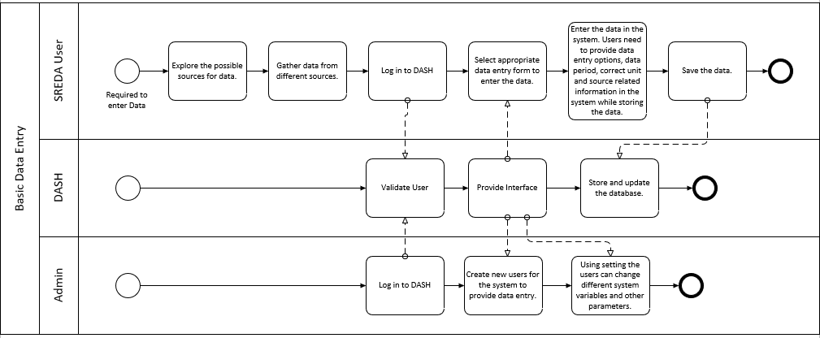

Figure 2. 2: Process Diagram for Data Entry (As Is)

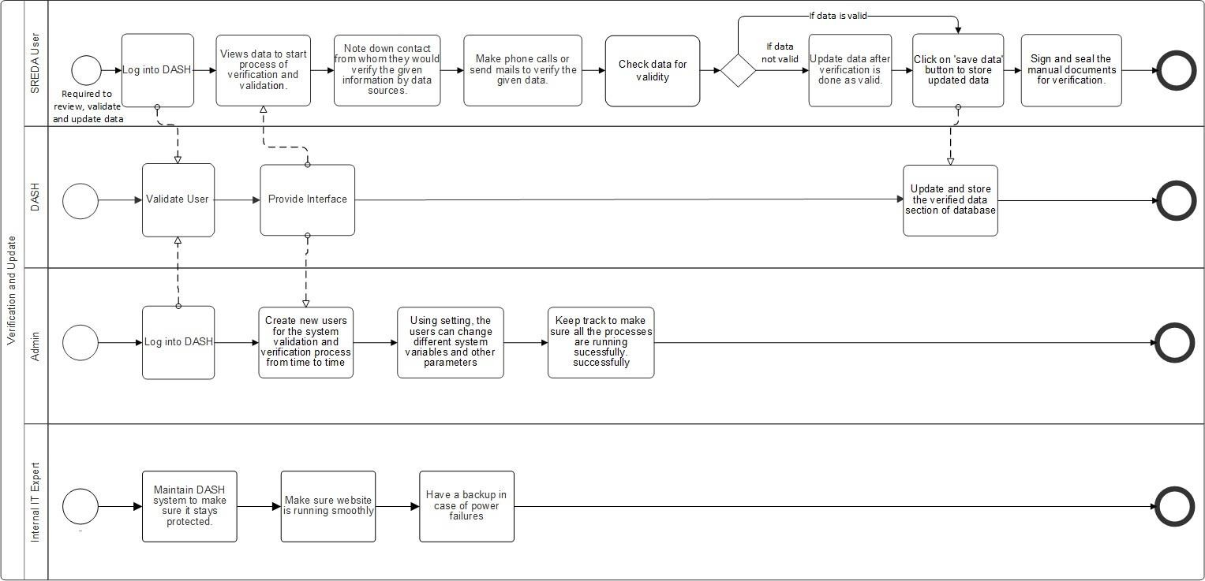

Figure 2. 3: : Process Diagram for Data Verification and Update (As Is)

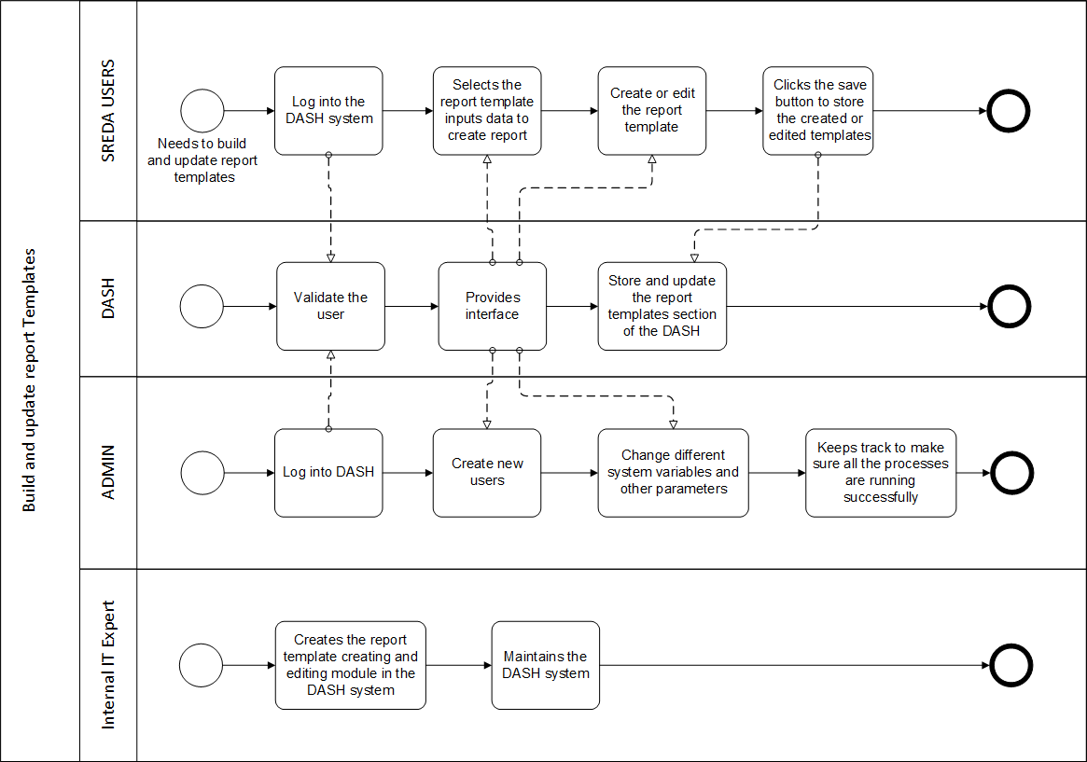

Figure 2. 4: Viewing (As Is)

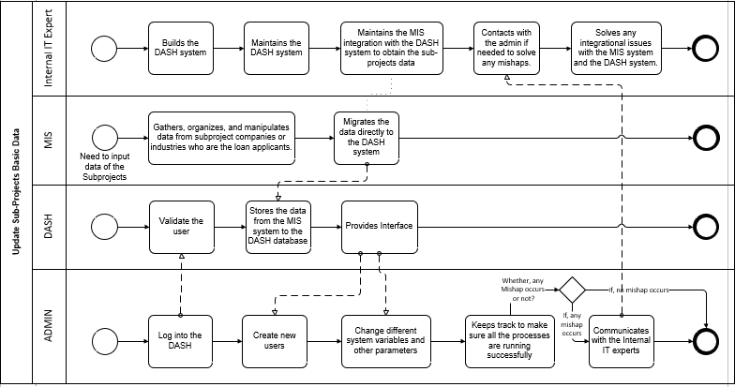

Figure 2. 5: Air Quality Report Generation (As Is)

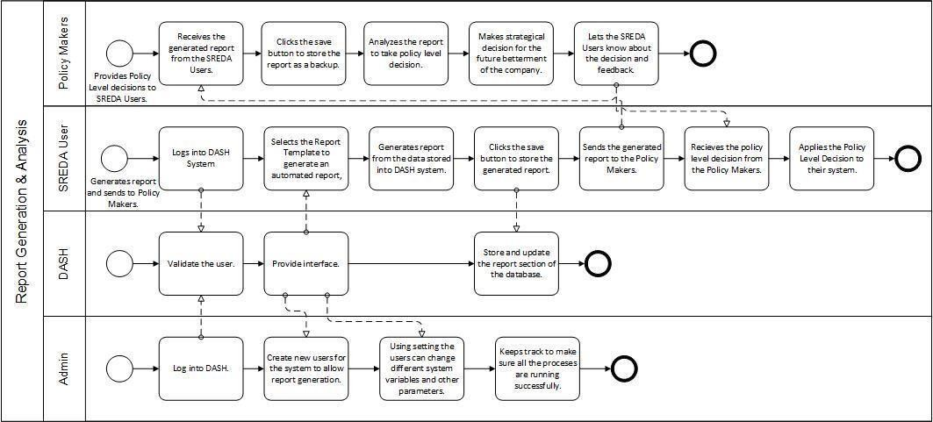

Figure 2. 6: Process Diagram for Report Generation and Analysis (As Is)



**PROBLEM ANALYSIS**

Table 2. 2 : Problem Analysis

|  |  |  |  |  |
| --- | --- | --- | --- | --- |
| Process name | Stakeholders | Concerns (Problems) | Analysis  (Reason of the problem) | Proposed solution |
| 1.Data entry and validation | A. Data Collector | 1. Data collector collects Datas from the data sources, which is mostly done by manually, and there is possibility to get faulty datas. At the same time this is very time consuming. | 1. The existing system gets the datas in two steps from the data sources ,it makes the procedure lengthy and it might be faulty in some cases. Firstly the data collectors collect datas and then give it to the data analyst to analyze the data then the data entry manager pushes it to the system. 2. There is no direct procedure for data collectors where they can entry datas directly to the system 3. They collect data in manual form which causes faulty datas. | 1. Re-built the AQM system data entry modules as per need of the system , where data manager will get the datas from the data source as csv file and will enter the datas to the system. 2. Data providers from the data sources can also enter datas directly to the AQM system.   3, There will be no manual data collection, everything will happen in an automated version. |

|  |  |  |  |  |
| --- | --- | --- | --- | --- |
|  | B.Data entry manager | 1.This is a lengthy procedure and time consuming as they have to wait for data Analysts. And there is no activity for faulty datas(after the data analyst analyzes datas). | 1. In the existing AQM system Data entry managers first get the data from data Analyst and then have to format it in a file from manual pdf of data. This is time consuming . 2. Entering thousands of data records manually requires a lot of time and unnecessary labour work.Also, AQM system is not validating, verifying the new data being entered as a result there is no surety of the new data being fetched into the system. | 1. Re-built the AQM system data entry modules as per need of the system , where the data manager will get the datas from data sources in a csv file and then they can directly push the datas to the system. 2. 1. Re-built the AQM system data entry modules as per need of the system , where data providers from different data sources can enter data directly to the system. |
| 2. Data verification and update | A. Data analyst | 1. Identifies and manually jots down the particular timestamp in a physical document where data is found faulty and manually informs the Data Collector. 2. Upon receiving a message about the new changes made to the faulty data, he will again search for his physical document, manually compare each timestamp listed earlier | 1. Unable to directly indicate the problematic timestamp.Manually informing the Data collector slows down the process of verification. Again, manually jotting down each faulty data is a tedious process. 2. The whole process of manually searching and comparing for the particular timestamp from the updated data trend/ graph is time consuming. He can easily miss a particular timestamp as a result | 1. There is an in-built function in the AQM system which will directly notify users of concerns about the problem without any delay. 2. The faulty data in a particular timestamp will be received when a request for error data will be sent to the system which will be easily identified by the user. |

|  |  |  |  |  |
| --- | --- | --- | --- | --- |
|  |  | with the new updated data trend.Hence, slower and insignificant way of verification of data.  3. The communication done about the faulty data from Data Analyst to Data Source is done via phone calls, email etc which is very inefficient as this delays the process of instant verification of the data in the system. | data particularly there will still remain unchecked and unverified.  3.Data Analyst did not have any visual representation of the faulty data in a particular timestamp.  Manually Searching and accumulating faulty data is a huge task. The AQM system did not play any role in detecting that particular faulty data. | 3. AQM system will directly convert the CSV file(which consists of data) provided by the Data collector and the system will automatically update the particular timestamp where data was found faulty. Additionally, the AQM system will immediately show error and not let unvalidated data get into the database.Hence, data will always be validated. |

|  |  |  |  |  |
| --- | --- | --- | --- | --- |
|  | C. Data Source/ Data Collector | 1. Collecting data from multiple sources is time consuming and very tedious. 2. Data is not available all the time. 3. Data source organizations are at times unhelpful, uncooperative to share data. | 1. Data searching and gathering from multiple data sources is a tedious process. Stuff limitation also makes the process slower.  .Additionally, data collectors are always receiving data from the data sources in a compiled physical document which is not a validated, verified process as there remains a high possibility of corrupted data. | 1. Able to directly flag/ mark the particular timestamp in the data trends / graphs where data is found faulty. This is a much faster and efficient way of indication of the faulty data. 2. AQM system using its in-built function will automatically update the particular timestamp where data was found faulty. As a result, when Data Analyst observes the absence of flags in the updated datatrend/ graphs, it simply means that the system is updated, validated and verified. 3. AQM system’s in-built function allows Smart weather stations like IQ air, AirNow(data sources) to directly input data in the AQM system.As a result, the role of data collector is not required. This is both faster and beneficial for all the stakeholders. Also, there is no risk of inputting unvalidated data |

|  |  |  |  |  |
| --- | --- | --- | --- | --- |
|  |  |  |  | by data source as AQM immediately bounces back unvalidated data by showing error/warnings. Other data sources also provide the data in a CSV form which is a much faster way rather than physically documenting it. |
| 3.Report generation | A. Researcher and viewer | 1. Report generation was lengthy procedure 2. No records of previous data reports | 1. Report generation purpose they have to call the assistance and then they work on the report generation and they talk to the software developers for making changes. 2. There is no record of previous datas in the existing system.   . | 1. Re-built AQM system has a direct option for users to download the report;they have access to the system . 2. Users can search the report by the date also, it helps to find the previous records as well. |

|  |  |  |  |  |
| --- | --- | --- | --- | --- |
| 4. Viewing | A. Researcher and General Viewer | 1.The user can only receive the report and download them from the system. | 1.The Users cannot see any dash board or data graphs from where they can Analyze the data visually. | 1.More advanced interface where user can see the visual representation of data and can Research it. |



**RICH PICTURE (TO BE)**

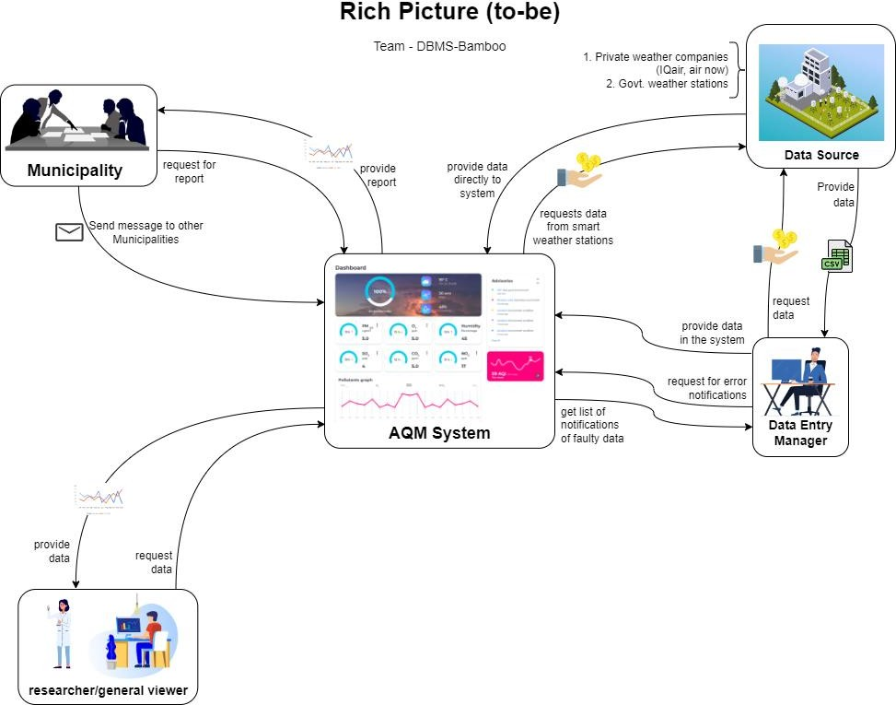

Figure 2. 7: Rich Picture (To Be)

Page | 39



**SIX ELEMENT ANALYSIS (TO BE)**

Table 2. 3: Six Element Analysis (To Be)

|  |  |  |  |  |  |  |
| --- | --- | --- | --- | --- | --- | --- |
| **Proces s** | **System roles** | | | | | |
| **Human** | **Non-computing Hardware** | **Computing hardware** | **Software** | **Database** | **Communication & Network** |
|  | **A. Data Sources** | **A. Paper and Stationery** | **A. PC/Laptop/Othe r computing device** | **A. AQM system** | **A. Database System of AQM system** | A. Internet used by Data Source, Data Entry Manager to log in, log out, viewing the AQM system.   1. Used when Data Entry Manager and Smart weather stations are inputting data into the AQM system. 2. Used when the AQM system is storing all the data. 3. Used when the AQM system automatically notifies Data Source and Data |
| **Data entry and validatio n** | 1. Logs into the AQM system. 2. Once identified as a validated user by the system, Data Source is allowed to enter the dashboard. 3. Enter the data as a CSV format directly. 4. Receives   notification from the system about the faulty data in a | 1. Paper is used by the Data providers for a backup copy of manual data sets. 2. Data Entry Manager can print the data and keep a manual database. 3. **Data Sheet in Printed Version**    1. The data sheet can be collected as a printed | 1. Computers, Mouse, Keyboards used by data entry managers and data providers for displaying, selecting, and inputting data on the AQM system.  **B. Scanner** | 1. Validate the User. 2. It provides an interface for the data entry manager and data providers for data entries. 3. The data providers from the data sources and the Data entry manager can use the AQM system to directly input their own data and generate reports for their own purposes.   **B. Operating System** | 1. Collection of data is entered into a database system of AQM by the data providers and the data  entry manager.  **B. MS Excel files** |

|  |  |  |  |  |  |  |
| --- | --- | --- | --- | --- | --- | --- |
|  | particular timestamp.  5. Logs out from the system.  **B. Data Entry Manager:** | version, by the Data Entry Manager.  **C. File Holder**  1. For holding the printed version of data sheets.  **D. Cabinets**  1. Cabinets used to store the Data sheets . | 1. Scanners to scan the data by data entry manager if they want to store the data manually. | 1. Any Operating System used by the data providers and the data entry manager like Mac, Windows, | 1. MS Excel files can be used to store the data by the data providers and the data entry manager. | Entry Managervice versa. . |
|  |  | C. **Application Softwar**e |  |  |
|  | **C. Servers** |  |  |  |
| 1. Logs in to the AQM system 2. Once identified as a validated user by the system, Data Entry Manager is allowed to enter the dashboard. 3. Enter the data as CSV format what is get by the data source. 4. If data is invalid then get the error notification, 5. Data Entry Manager can also see the faulty datas.. | 1. Database servers used by the AQM system for data providers,data entry manager and for data entries   1. **Router/**   **Internet Cables by ISP Providers/ Switch**   * 1. From the   networking side, internet cables by the ISP providers or | 1. Application software used by the data providers and the data entry manager like MS Excel.  **D. Scanning Software**  1. Data can be scanned by the data entry manager if they want to store the data manually.  **E. Printing Software** | **C. MySQL**  1. The data providers can also use database systems like MySQL to store the raw data. |  |

|  |  |  |  |  |  |  |
| --- | --- | --- | --- | --- | --- | --- |
|  | 6. Logs out from the system. |  | router or switch used by the data provider and Data entry manager. | 1. Printingsoftware used for printing the data sheet like Printer Management or HP Print and Scan Doctor.  F. **PDF Viewer**  1. Software used to view the PDF like WPS |  |  |
| **Data verificati on and update** | 1. **Data Entry Manager**    1. Logs into the AQM system    2. Once identified as a validated user by the system, Data Entry Manager is allowed to enter the dashboard.    3. Receives   notification from the system about the faulty data in a particular timestamp.   * 1. Views the data trends/ graphs. | 1. **Paper and stationary**    1. Papers used for printing purposes by the Data Entry Manager.    2. Pen used by the Data Entry Manager if needed to write down any particular query about faulty data. 2. **File Holder**    1. For holding the printed version of the compiled verified physical document of data as a manual backup. 3. **Cabinet** | 1. **PC/ Laptop/ Other computing device**    1. Used by the Data Entry Manager to observe and analyze the data trend/ graphs.    2. Used by Data Entry Manager to store the verified and updated data in the computer as a backup. | 1. **AQM System**    1. The system validates and verifies the users.    2. Provides an appropriate interface for the users.    3. Used for viewing the monthly Air Quality data trends/ graphs by Data Entry Manager.    4. Stores data inputted by Data Entry Manager and Smart weather stations.    5. Stores flagged/ marked faulty data in the particular timestamp.    6. Used to send and receive notification from Data Entry Manager, Data Source.    7. Converts the CSV form provided by Data Entry | 1. **Database of AQM System**    1. AQM database stores information of all the appropriate users.( this is useful while the system validates the user while logging in into the system)    2. AQM database stores data provided by Data Source and Data Entry Manager.    3. After new data is inputted(to replace the faulty data in the particular | **A. Internet**   1. Internet connection used by Data Source, Data Entry Manager to log in, log out, viewing the AQM system. 2. Used when Data Entry Manager and Smart weather stations are inputting data into the AQM system. 3. Used when the AQM system is storing all the data. 4. Used when the Data Analyst is |

|  |  |  |  |  |  |  |
| --- | --- | --- | --- | --- | --- | --- |
|  | 1. Sees that particular data has been flagged/ marked by the system as faulty data. 2. Requests Data Source to provide data again for that particular timestamp where data was found faulty. 3. Receives new dataset from Data Source in CSV format. 4. Inputs the new dataset in the AQM System particularly where data was flagged/ marked. 5. Notifies Data Analyst about the updated changes in the data trend/ graph. 6. Logs out from the AQM system.   **C. Data Source** | 1. It is used for storing the printed data version (the physical document) as a manual backup  .   1. **Printed Datasheets**    1. Data Entry Manager can keep the printed datasheets as a manual backup for future references(can use it to compare before after data if needed) | 3. Data Entry Manager also can store the CSV received from the Data Source in the computer as a backup.  **B. Printer**   1. Used by the Data Entry Manager for printing the data sheet for manual backup.   **C. Server**   1. Database uses the server to store the updated air quality data trends/ graphs. 2. The AQM System is hosted on the server. 3. The data in the AQM System is provided from the server. 4. AQM system uses the Database server to let the Data | Manager into graphical representation using an in- built function.   1. System checks and validates the data provided by both the Data Entry Manager and Smart weather station using an in-built function. 2. Immediately gives error/ alert if data inputted does not match system’s validation in-built function. 3. Requests Data Entry Manager to re-input correct dataset again in the particular timestamp where data failed to be validated. 4. Requests for data from Smart weather station for the particular timestamp where data failed to be validated 5. Update the data in the particular faulty timestamp 6. Store the validated, verified and updated data in the system.   **B. Operating System**  1. Any operating system used by Data Entry | timestamp) by Data Entry Manager and Smart weather station, Database is validated , verified and updated using the in-built function.   1. This update change is viewed by the Data Entry Manager. 2. After the faulty data has been validated and verified, the new updated   and verified data is stored in the AQM database.  **B. Physical log book**  1. Used by Data Entry Manager to store the printed datasheets as a manual backup for future references(if needed).  **C. MySQL** | flagging/ marking the faulty data.   1. Used when the AQM system automatically notifies Data Source and Data Entry Manager vice versa. 2. Used when AQM system updates the specified faulty data automatically using the in-built function. 3. Used when the AQM system stores the updated and verified air quality report in the system. |

|  |  |  |  |  |  |  |
| --- | --- | --- | --- | --- | --- | --- |
|  | 1. Receives   request for recollecting data for a particular timestamp from Data Entry Manager and directly from the AQM system.   1. Gather air quality data from the enlisted sources for that particular timestamp. 2. Provides data by sending a dataset in CSV format to the Data Entry Manager. 3. Smart weather stations directly provide data into the AQM system. |  | Entry Manager view/analyze/ob serve all the data trends and graphs.   1. **Routers/ Internet Cables by ISP Providers**    1. From the   networking side, internet cables by the ISP providers or router are used by the Data Entry Manager. | Manager Eg : Mac, Windows, Linux etc  **C. Application Software**  1. Data Entry Manager can initially make a draft of the datasheet provided by the Data Source in MS Word/ Ms Excel.   1. **PDF Viewer**    1. Data Entry Manager can view the data trends / graphs in the pdf version.    2. Data Entry Manager can view the datasheet in PDF version. 2. **Web- based Application Software**    1. Data Entry Manager use browser to log in into the AQM system.    2. Data Entry Manager use to view the data trends/ graphs.    3. Data Analyst use to store the verified and updated data on the AQM system. 3. **Printing Software**    1. Printing software used for printing the data sheets by Data Entry Manager as manual backup. | 1. Data Entry Manager stores all the CSV files in the MySQL database to avoid losing it in the future. 2. Data Entry Manager stores the datasheets here. 3. Stores all the information related to air quality reports in the MySQL database.   **D. Excel file**   1. Used by Data Entry Manager to store   the specific timestamps where data was found faulty. |  |

|  |  |  |  |  |  |  |
| --- | --- | --- | --- | --- | --- | --- |
|  |  |  |  |  |  |  |
| **Report generatio n And Anaysis** | **Researchers/General viewers**   1. Researchers/Ge neral viewers log into the AQM system 2. Once they get into this there they will see all the reports which will show the Graph of datas,charts of datas. 3. Researchers/Ge neral viewers also can search the Reports by date. 4. Makes analysis as much as needed 5. Logs out of the system | **Paper and Stationery**   1. Data entry Manager,Researchers/g eneral viewers might also need to take notes on the report. 2. For manual verification and calculation pen and papers are used. 3. For printing purpose   **B. PDF version**  1. It might be needed for research and analyzing purposes.  **C. Printed Version**  1. If Data providers,Data entry managers and researchers/general viewers want to store | 1. **PC/ Laptop/ Other Computing Devic**e    1. It is used by the Data providers,Data entry managers and researchers/gen eral viewers for viewing and downloading the report.    2. Reports can be stored inside the computing device by Data providers,Data entry managers and researchers/gen eral viewers.    3. Can be used for searching for research purposes. 2. **Printer** | 1. **AQM System**    1. It provides an interface which stores the data and gives a report to the Data providers,Data entry managers and researchers/general viewers.   **B. Operating System**  1. Any Operating System used by the Data providers,Data entry managers and researchers/general viewers like windows  ,mac.  **C. Application Software**  1. Data providers,Data entry managers and researchers/general | 1. **AQM Database System**    1. To store the report into the AQM system by themselves as a record. 2. **MySQL**    1. Data Entry Manager can store the reports for further research purposes in MySQL Database to avoid losing them. 3. **Printed Version**    1. Printed version of the report can be stored | A. Internet   1. connection used by Data Source, Data Entry Manager   ,Researcher or general viewers to log in, log out, viewing the AQM system.   1. Used when Data Entry Manager,Data Source or Any User want to download a Report like graph,chart from the AQM system. 2. Used when Data Entry Manager ,Data Source or any other user want to search any report by date. |

|  |  |  |  |  |  |  |
| --- | --- | --- | --- | --- | --- | --- |
|  | 1. **Municipality**    1. **Logs into the system**    2. **Once validated, enters the dashboard.**    3. **Analyses the charts/ graphs**    4. **Requests to download the report**    5. **Once requested has been accepted, downloads the reports.**    6. **If needed to communicate with other municipality, needs message through the system.**    7. **Discuss and make strategical decisions based upon reports.**    8. **Logs out from the system** | the report as the printed version.  **D. Cabinet**  1. For storing the report which was printed as manual backup by the executives or the software developers.  **E File Holder**  1. For holding the printed version of the reports. | 1. For printing the report for manual backup by Data providers,Data entry managers and researchers/gen eral viewers.  **C. Scanner**   1. To scanning the reports by   the Data providers,Data entry managers and researchers/gen eral viewers  **D. Routers/ Internet Cables by ISP Providers/ Switc**h | viewers can view the report.  **D. Web-based Application Software**  1. Data providers,Data entry managers and researchers/general viewers will use browsers to login ……  **E. Scanning Software**  1. Reports can be scanned by the Data providers,Data entry managers and researchers/general viewers if they want to store the data manually.  **F. Printing Software**  1. Printing software used for printing reports as a manual backup by  the Data providers,Data entry managers and | as a manual backup by the Data  providers,Data entry managers and researchers/ge neral viewers. |  |



**PROCESS DIAGRAM (TO BE)**

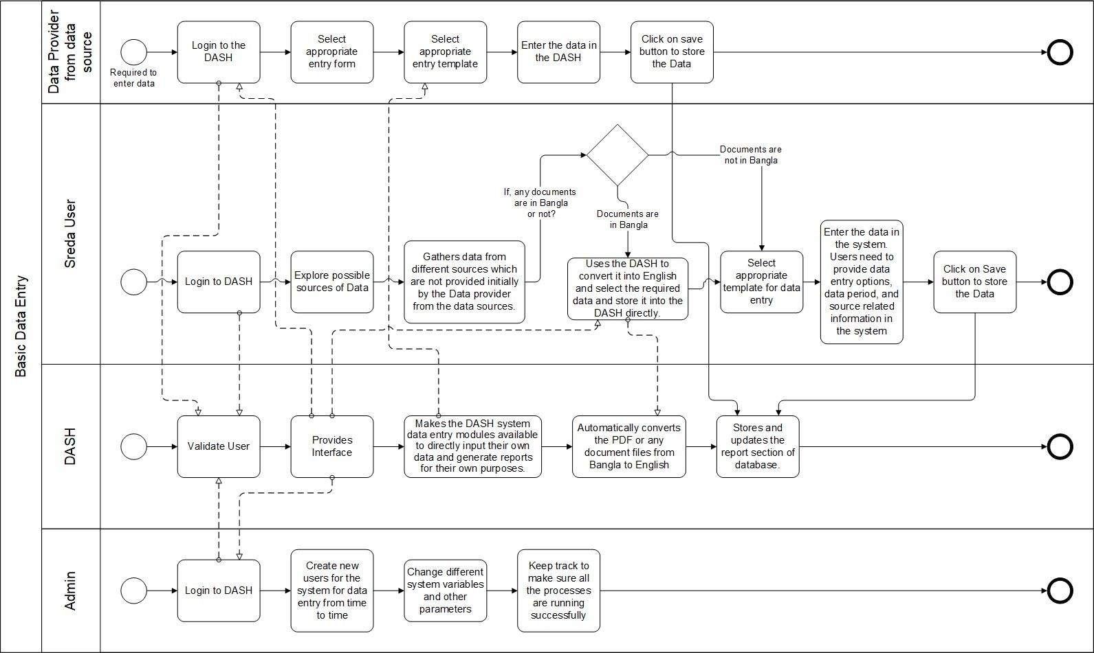

Figure 2. 8: Process Diagram for Data Entry (To Be)

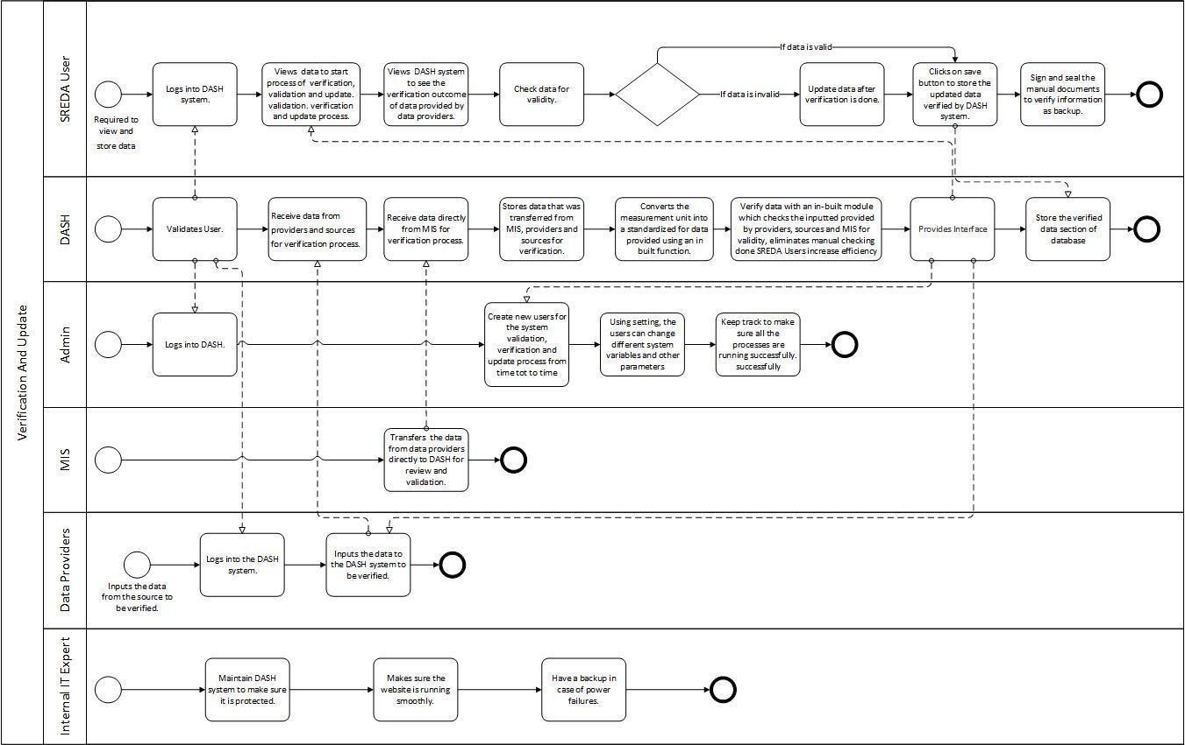

Figure 2. 9: Process Diagram for Data Verification, Validation and Update (To Be)

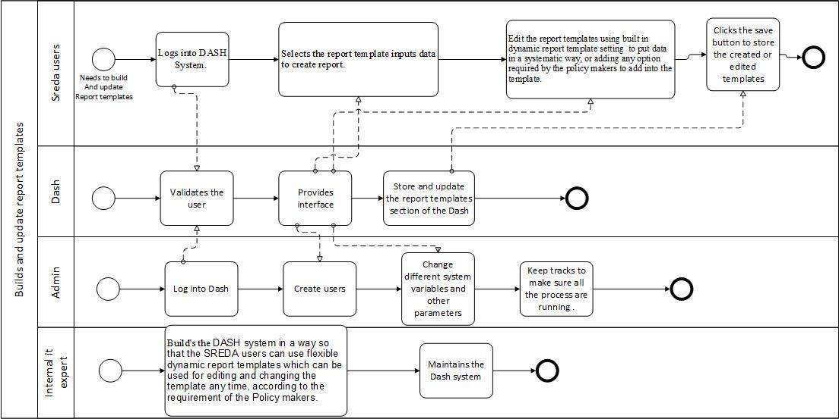

Figure 2. 10: Process Diagram for Report Generation and Analysis (To Be)



**CHAPTER 03 : LOGICAL SYSTEM DESIGN**



**BUSINESS RULE**

Air Quality Monitoring(AQM) system is a data-driven software system for monitoring the air quality of Bangladesh. The goal of this proposed system is to mainly provide maps and charts for monitoring the current and future Air Quality Index (AQI) of any area in Bangladesh. The following Business Rule describes the situation that a AQM database must model:

The data is collected from the sensors and satellites of different stations covering multiple areas. The stations, which is acting as the Data-Source can either be of mobile sensor based devices , or a weather station, but not both. Both the Data-Source will have an ID and the organization name.

The model number should be recorded for each mobile sensor devices and the locations of the weather station should also be recorded.

Each mobile sensor device gives mobile sensor data which is destroyed when the mobile sensor device is discontinued. Similarly, each weather station gives weather station data which is destroyed when the weather station itself is discontinued. Mobile sensor data have a daily data,PM2.5,temperature , longitude, latitude, and timestamp. Weather station have a monthly data, PM2.5, rain precipitation, wind speed, visibility, cloud cover, relative humidity, and timestamp. Mobile sensor device may give multiple mobile sensor data but mobile sensor data will always have a mobile sensor device. Likewise, weather station may give multiple weather station data but weather station data will always have a weather station.

There will be a User which can either be Municipalities or Ministry, but not both. Municipalities and Ministry can intercommunicate about the data and comment about it. The message passed has to be recorded in the database. User will have a name, password, email. District name for Municipality should be recorded and ministry name for Ministry should be recorded.

Figure 3. 1: Entity Relationship Diagram of AQM System

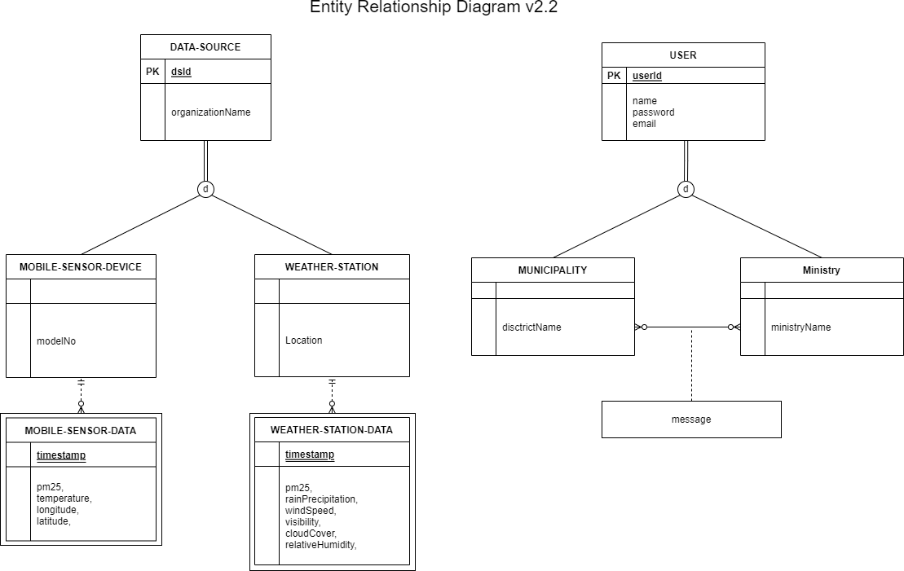

**Entity Relationship Diagram**



**ENTITY RELATION DIAGRAM TO RELATION SCHEMA**

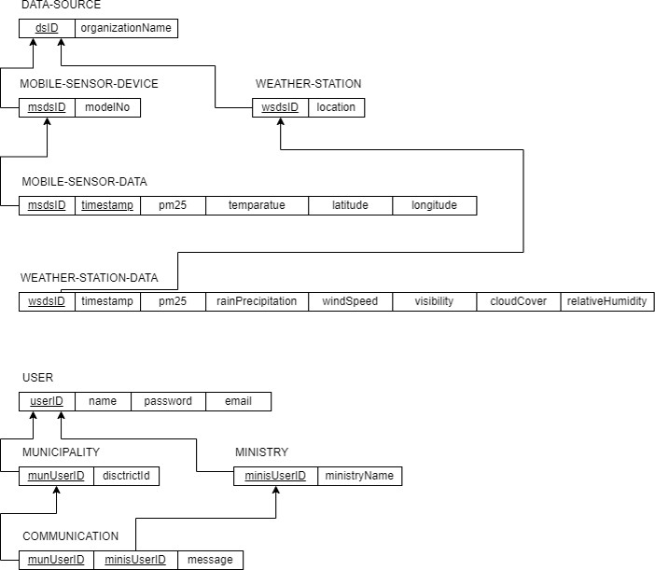

Figure 3. 2: Entity Relation Diagram to Relation Schema for SREDA



**NORMALIZATION**

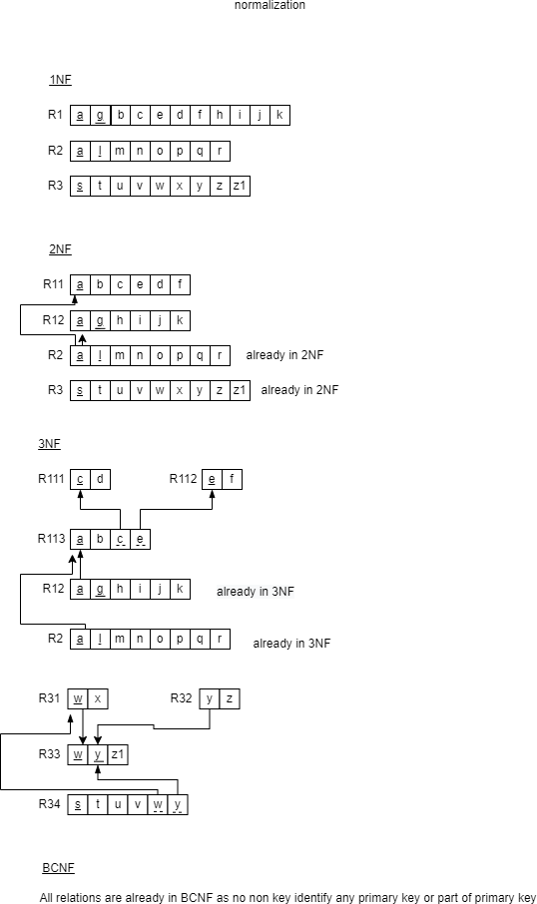

Figure 3. 3: Normalization for SREDA



**DATA DICTIONARY**

Table 3. 1: mobile_sensor_table

|  |  |  |  |
| --- | --- | --- | --- |
| **Name** | **Data Type** | **Size** | **Remark** |
| msDsID | INT |  | This is the primary key of this relation. This contains the ID of the mobile sensor data source.  Example: 12345 |
| modelNO | VARCHAR | 45 | This attribute contains the model no of mobile source data source. Example: “abc25367” |

Table 3. 2: weather_station_table:

|  |  |  |  |
| --- | --- | --- | --- |
| **Name** | **Data Type** | **Size** | **Remark** |
| wsDsID | INT |  | This is the primary key of this relation. This contains the ID of the weather station data source.  Example: 12345 |
| location | VARCHAR | 45 | This attribute contains the location of weather stations.  Example: “Bashundhara” |

Page | 84

Table 3. 3: data_source_table

|  |  |  |  |
| --- | --- | --- | --- |
| **Name** | **Data Type** | **Size** | **Remark** |
| dsID | INT |  | This is the primary key of this relation. This contains the ID of the data source table. Example: 12345 |
| organizationName | VARCHAR | 45 | This attribute contains the organization name of data source.  Example: “IqAir” |

Table 3. 4: mobile_sensor_data_table

|  |  |  |  |
| --- | --- | --- | --- |
| **Name** | **Data Type** | **Size** | **Remark** |
| date | DATE | DD-MM-YY | This contains the date when the data is taken.  Example:”26-08-2022” |
| pm2.5 | DOUBLE |  | This attribute contains the value of pm2.5 which is taken by a mobile sensor.  Example: 231.5 |
| temperature | DOUBLE |  | This attribute contains the value of temperature which is taken by a mobile sensor.  Example: 20.5 |
| longitude | DOUBLE |  | This attribute contains the value of longitude which is taken by a mobile sensor.  Example: -87.345235 |
| latitude | DOUBLE |  | This attribute contains the value of latitude which is takenPabgye |a8m5 obile sensor.  Example: 41.345235 |
| dsId | INT |  | This is the primary key of this relation. |

Table 3. 3:weather_station_data_table

|  |  |  |  |
| --- | --- | --- | --- |
| **Name** | **Data Type** | **Size** | **Remark** |
| date | DATE | DD-MM-YY | This contains the date when the data is taken.  Example:”26-08-2022” |
| pm2.5 | DOUBLE |  | This attribute contains the value of pm2.5 which is taken by the weather station.  Example: 231.5 |
| rainPrecipitation | DOUBLE |  | This attribute contains the value of rain precipitation which is taken by the weather station.  Example: 0 |
| windSpeed | DOUBLE |  | This attribute contains the value of wind speed which is taken by the weather station  Example: 9.2 |
| visibility | DOUBLE |  | This attribute contains the value of visibility which is taken by the weather station  Example: 2.7 |
| cloudCover | DOUBLE |  | This attribute contains the value of cloud cover which is taken by the weather station  Example: 16.3 |
| relativeHumidity | DOUBLE |  | This attribute contains the value of relative humidity which is taken by the weather station Example: 73.17 |
| dsId | INT |  | This is the primary key of this  relation. This contains the ID of the data source. Example: 12345 |

Table 3. 4: user_table

|  |  |  |  |
| --- | --- | --- | --- |
| **Name** | **Data Type** | **Size** | **Remark** |
| userId | VARCHAR | 20 | This is the primary key of this relation. This contains the ID of the user. Example: “ab2344” |
| name | VARCHAR | 45 | This attribute contains the name of the user.  Example: “BambooDs” |
| email | VARCHAR | 45 | This attribute contains the email address of the user.  Example: “[Bamboo.ds@gmail.com](mailto:Bamboo.ds@gmail.com)” |
| password | VARCHAR | 45 | This attribute contains the password of the user.  Example: “bAmboo123” |
| designation | VARCHAR | 45 | This attribute contains the designation of the user.  Example: “Student” |
| dept | VARCHAR | 45 | This attribute contains the department of the user.  Example: “ABC” |

Table 3. 5: message_table

|  |  |  |  |
| --- | --- | --- | --- |
| **Name** | **Data Type** | **Size** | **Remark** |
| userId | VARCHAR | 20 | This is the primary key of this relation. This contains the ID of the user. Example: “ab2344” |
| message | LONGTEXT |  | This attribute contains the message.  Example: A problem detected. |
| timestamp | DATETIME | yy-MM-dd HH:mm:ss | This attribute contains the timestamp.  Example: 10-04-19 11:05:23 |



**CHAPTER 04 : PHYSICAL SYSTEM DESIGN**



**INPUT FORMS**

* 1. Login Page

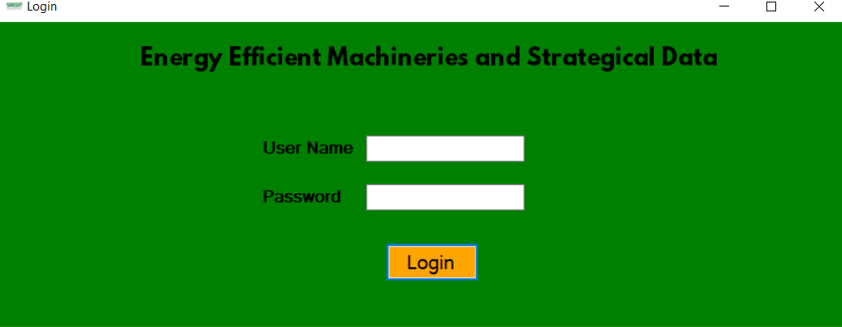

Figure 4. 1: Login Page

# SQL :

Login Page SELECT *

FROM sreda.login

WHERE user_name='" & TextBox_UN.Text & "' and password='" & TextBox_PASS.Text & "'

* 1. Add air quality data using form
  2. Add various types of Air quality data using from a CSV file



**OUTPUT FORMS**

* 1. Location-based daily Air Quality Index (AQI) visualization in a dashboard 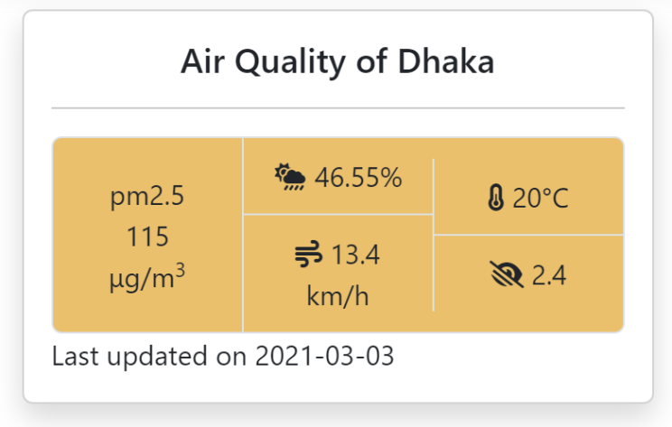

Page | 125

# SQL :

SELECT ws.location, pm25, date FROM weather_station_data_table wsData, weather_station_table ws, data_source_table ds WHERE wsData.dsID = ds.dsID AND ws.wsDsID = ds.dsID AND ws.location = 'dhaka' ORDER BY date DESC LIMIT 1

2. Comparison between multiple data sources

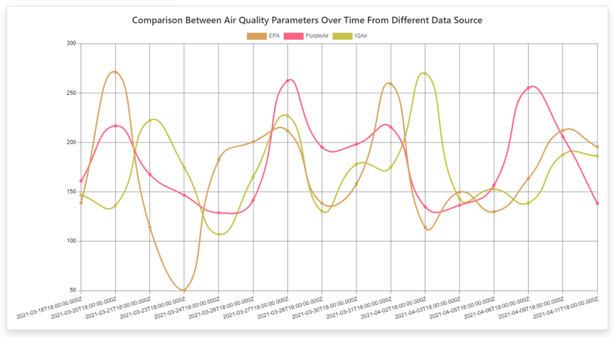

**SQL:**

SELECT distinct(t1.date), t1.pm25, t1.organizationName, t2.pm25, t2.organizationName, t3.pm25, t3.organizationName FROM (SELECT date, pm25, organizationName FROM mydb.weather_station_data_table WHERE organizationName = 'EPA') as t1, (SELECT date, pm25, organizationName FROM mydb.weather_station_data_table WHERE organizationName = 'PurpleAir') as t2, (SELECT date, pm25, organizationName FROM mydb.weather_station_data_table WHERE organizationName = 'IQAir') as t3 WHERE t1.date = t2.date AND t1.date=t3.date ORDER BY t1.date

1. Equipment-Wise Distribution Chart

Purpose : This chart shows the percentage of euipments being used per billion in BDT.

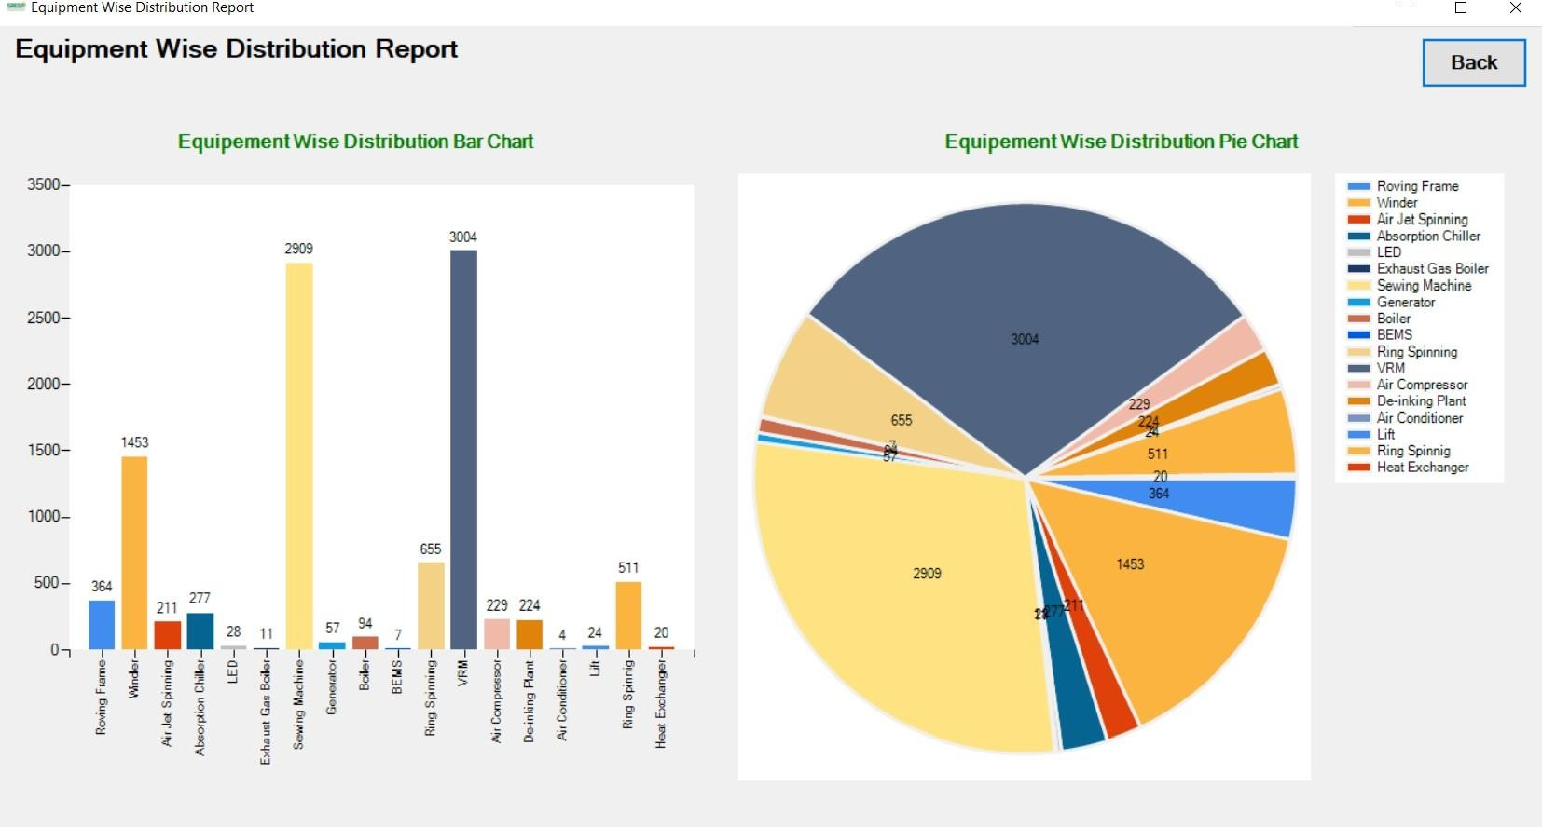

Figure 4. 20: Equipment-Wise Distribution Chart

Page | 132

# SQL :

SELECT specification AS Equipment, SUM(quotedprice) AS AmountInMillionBDT FROM sreda.subprojectdataequipment

GROUP BY specification

Page | 133

1. Sector-Wise Distribution Chart

Purpose : This chart shows the percentage of type of sectors per billion in BDT..

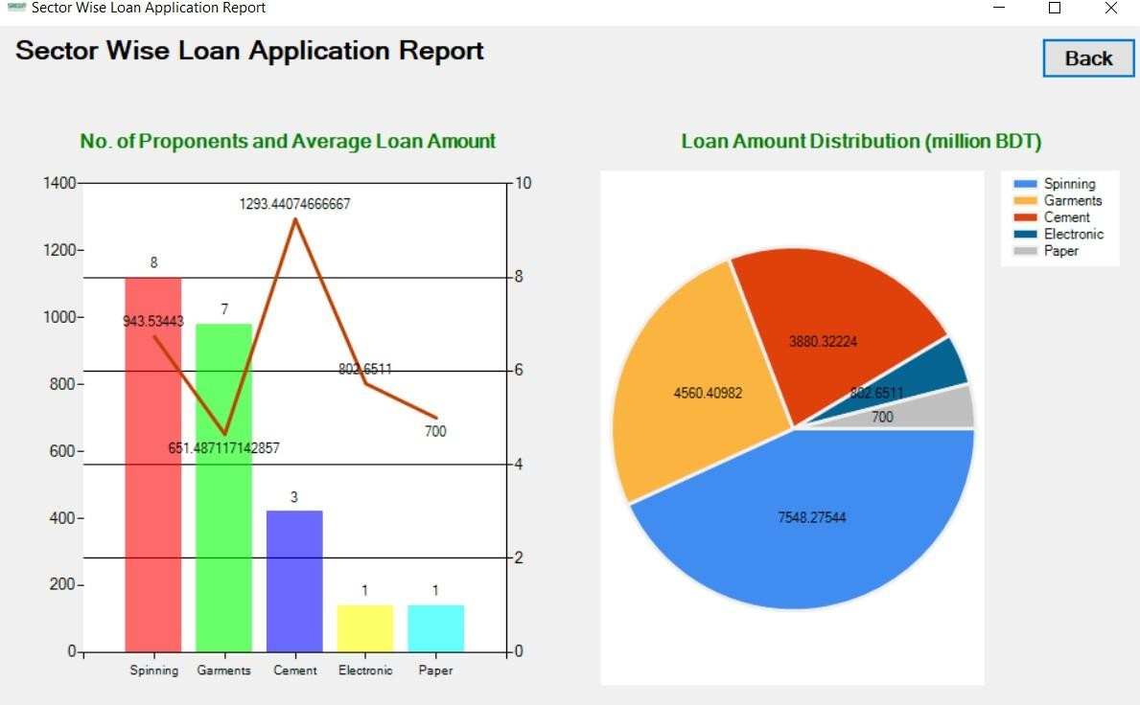

Figure 4. 21: Sector-Wise Distribution Chart

Page | 134

# SQL :

SELECT lineofbusiness AS LOB, COUNT(lineofbusiness) AS NoOfProjects, SUM(loanAmount) TotalLoanAmount, (SUM(loanAmount)/COUNT(lineofbusiness)) AS AvgAmountPerProject

FROM sreda.loanapplication GROUP BY lineofbusiness



**CHAPTER 05 : CONCLUSION**



**PROBLEM AND SOLUTION**

* 1. As there is not so much information about the Air Quality Monitoring System on the internet apart from some websites, but it is mostly about the Air Quality Monitoring device that is why we could not input any extra information other than the ones our instructors filled us in with.
  2. Since some of us heard about this project for the first time from our faculty, it took quite a long time for us to grasp what this government project was about.The required information was provided by our faculty. Mostly we heard about the air quality monitoring device.



**ADDITIONAL FEATURE AND FUTURE DEVELOPMENT**



**CONCLUSION & RECOMMENDATIONS**

Through the implementation of this project we get to know the limitations of the solution of the Air Quality Monitoring System. So we proposed a data driven software system that will be used to monitor and ensure the air quality of Bangladesh. The main purpose of this project is to improve air quality and to establish a low cost solution for improving Air quality by monitoring the air standard. And our main motive was to automate the system mostly



**REFERENCES**

[1]].